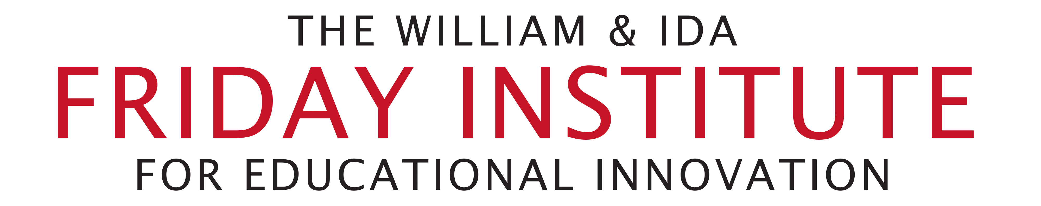

Visit to Suzhou North American High School
May 28, 2018

Business Meeting Agenda

Phase II
Year 1 – July 1, 2017 – June 30, 2018
Year 2 – July 1, 2018 – June 30, 2019

Phase III – July 1, 2019 – June 30, 2021
- New Literacies Teacher Leader Institute
- Teacher Recruitment
- PBI Global Student Summit
- On-Call Curriculum Support
- Teacher Working Conditions Survey
- NC State Study Abroad
- Research and Presentations

