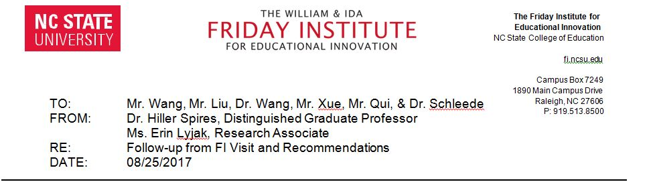

I. SNA: Top-Level Action Items to Support School Innovation
  - Reconcile Western-style curriculum with Chinese-style management approach
    - Increase communication levels by:
      - Conducting all school meetings with bilingual translation
  - Support English as language of instruction for Chinese students
    - Adopt the instructional philosophy of All Teachers Teach English by
      - Providing extensive professional development for all teachers to teach in English within their disciplinary content area
    - Setting aside time for interdisciplinary instructional planning for teachers to collaborate on TOEFL preparation and disciplinary content area learning needs area (including attending QTEL Summer Institute)
  - Create School Improvement Committee
    - Establish a school improvement committee comprised of 3 international teachers, 1 local teacher, 2 administrators, 1 parent, and 1 student
    - Have the school committee establish top three goals based on school data, implementation create strategies and assess completion
  - Provide opportunities for professional development and leadership for Administrators
    - Attend professional conferences, provide keynote speeches and presentations at conferences, and visit other international schools

- SNA: Action Items Based on Going from Good to Great Ideas
- Cultivate top talent
  - Recruit and retain top-level teachers
  - Create a faculty culture of inclusivity

- Engage in intentional thought
  - Create coherence between SNA’s vision and systems/structures of SNA
  - Create coherence between SNA’s mission and curriculum implementation

- Take intentional action
  - Recommit to a shared vision and mission for SNA
  - Maintain an accurate organizational chart, including roles and responsibilities
  - Merge international and local teacher recruitment and human resource service
  - Offer competitive employment packages for local and international packages
  - Continue to network with international schools and organizations throughout the world

- Make the leap to greatness endure over time
  - Create short-term and long-term indicators of success (i.e., quality control)
  - Design forward-thinking structures (e.g., multi-year school calendar, master schedule, projected student growth with necessary staff, weekly bilingual school/staff newsletters)

Additional Logistical Recommendations
- Secure seating for at least 1,000 people in one room (e.g., collapsible bleachers in the gymnasium)
- Convert open space (above the café) on 4th floor into teachers’ lounge
- Ensure stable and consistent WiFi access for all students, faculty, and staff
- Supply tissues, soap and paper towels in all bathrooms for personal hygiene and public health
- Furnish library with wide selection of international books

