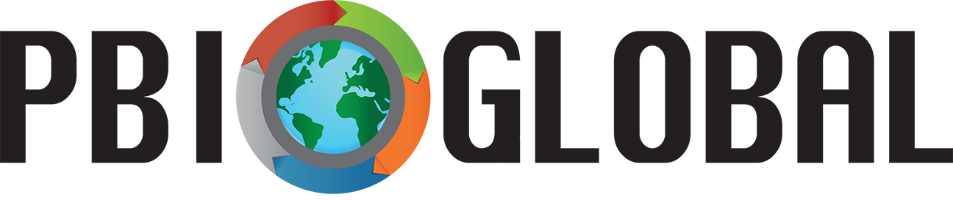

Thank you for agreeing to be an external expert for the PBI Global Student Summit 2018!

Students are conducting cross-cultural inquiry on the theme “A World on the Move: Migrants and Refugees.” Each team has developed a compelling question (CQ) that they are answering through an iterative design process in which they gather and analyze sources; creatively synthesize claims and evidences; and critically evaluate and revise. You will be providing another opportunity for students to critically evaluate and revise their
- Public Service Announcement (iMovie Trailer) and
- Team Presentation of Research.

This feedback is essential as students prepare to share, publish, and act as a result of their inquiry at the PBI Global Student Summit Showcase on May 30, 2018.

We ask that you provide students with feedback on the intellectual, technical and aesthetic, and language structure quality of the aforementioned PBI Global products. Here are your team assignments:
- Team 1 – Jeremy Kleiman & Rachel Kleiman
- Team 2 – Dr. Glenn Kleiman
- Team 3 – Dr. Paola Sztajn
- Team 4 – Dr. Hiller Spires
- Team 5 – David Schwenker
- Team 6 – Dr. Elizabeth Miller

You will be providing feedback to the teams across two days at the Summit (Monday, 5/28, and Tuesday, 5/29). Day one feedback will focus on the students’ PSAs while day two will be for team presentations. We encourage you to work closely with students as they make the revisions and edits you suggest.

Please use the attached feedback forms to provide your team with suggested revisions and edits. We really appreciate your support in making PBI Global a success!
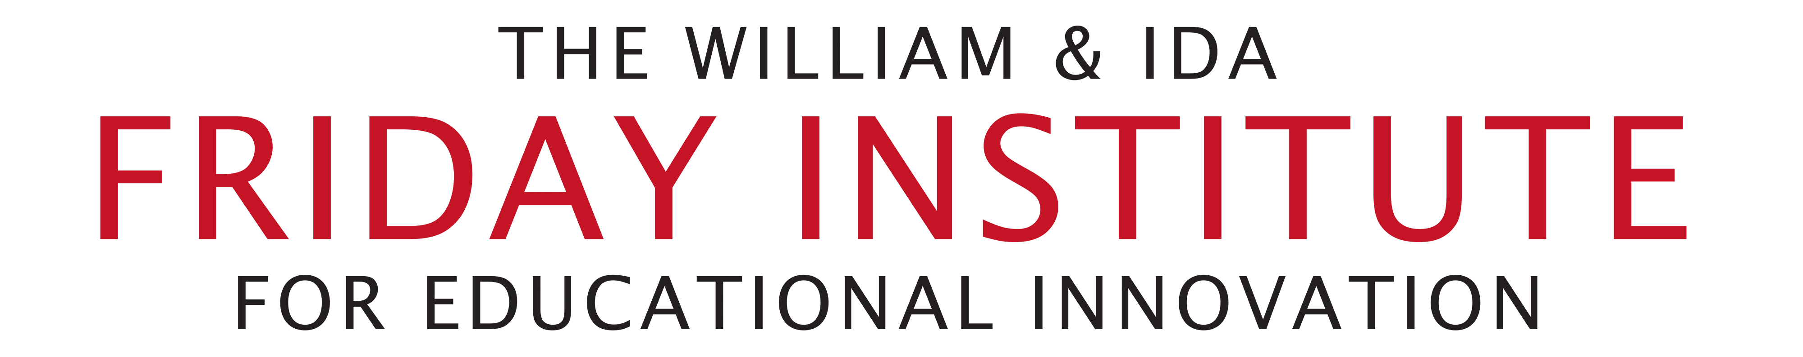

PBI Global Feedback Form – Public Service Announcement (iMovie Trailer)
External Expert Comments for Team __

 | + - Done Well | ∆ - Needs Improvement
Intellectual Quality
- Inquiry is thought provoking and well developed.
- Project is clearly supported with thorough and insightful research.
- Thoroughly synthesizes and constructs clear ideas from research gathered.
- Research is fully and correctly cited.

Aesthetic and Technical Quality
- Ideas in Public Service Announcement (PSA) are clear, complete, and persuasively expressed for a general audience.
- PSA demonstrates original personal expression that greatly enhances the purpose of inquiry.
Language Structure Quality
- All written and spoken language is well constructed with no errors in grammar, mechanics, and/or spelling.
- Uses vivid words and phrases. The choice and placement of words seems accurate, natural, and not forced.
- Purpose of written and spoken language is very clear, and there is strong evidence of attention to audience.

PBI Global Feedback Form – Team Presentation of Research
External Expert Comments for Team __

 | + - Done Well | ∆ - Needs Improvement
Intellectual Quality
- Shares clear purpose and subject; pertinent examples, facts, and/or statistics; supports claims with evidence.
- Properly attributes information to source materials.
- Substantially increases audience understanding and knowledge of topic.
- Convinces audience to recognize the validity and importance of the inquiry topic.

Aesthetic and Technical Quality
- Holds attention of audience through use of eye contact.
- Speaks with fluctuation in volume and inflection to maintain audience interest and to emphasize key points.
- Demonstrates passion about inquiry topic during entire presentation.
- Draws clear connections between visual products (i.e., infographic and PSA) and research presentation.

Language Structure Quality
- All written and spoken language is well constructed with no errors in grammar, mechanics, and/or spelling.
- Uses vivid words and phrases. The choice and placement of words seems accurate, natural, and not forced.
- Purpose of written and spoken language is very clear, and there is strong evidence of attention to audience.

